As per the specification, I registered into the Pubnub account and get both ‘publish key’ and ‘subscribe key’ and created two HTML files for ‘Control room’ and ‘Submarine’ page and I have uploaded the same in repository.

**Control room page : ‘controlRoom.html’**

Functionality: Please find the screen shot.

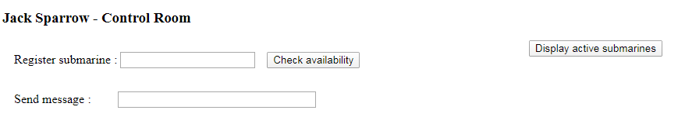

Once, user enter the submarine name and click on ‘Check availability’ button it will check that submarine was already subscribed or not. If not then allow to register else giving message to the end user with historical information as below.

**If not subscribe**

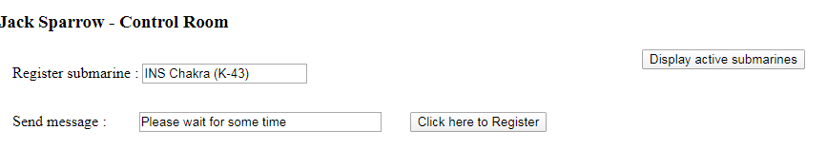

Once click on Register button, the above submarine was subscribed and send the message to all within the channel group and also dynamically created one button to hide the submarine.

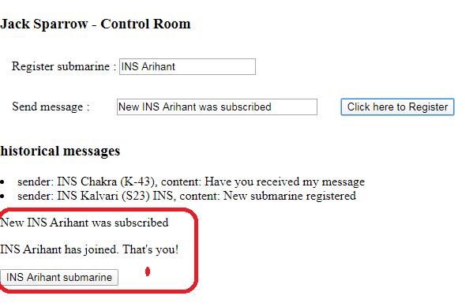

**If already subscribed:**

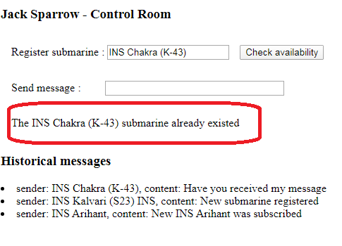

**Displaying all active submarines**

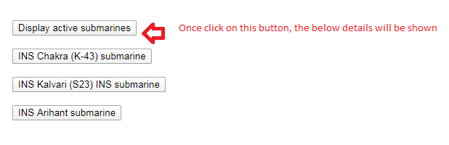

**Submarine page : ‘submarine.html’**

Here, I am using the same functionality like., check availability and registration process (Subscription).

Once we open this page, I am showing all historical messages to check whether we are getting messages from the control room.

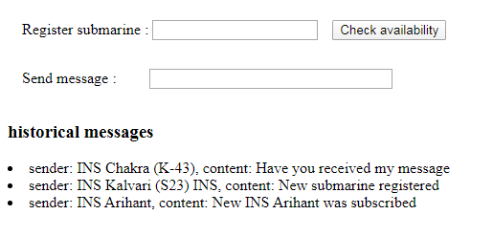

**If already subscribe.**

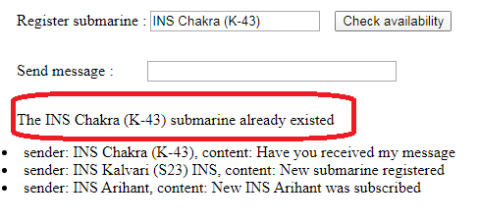

**If not already subscribe**

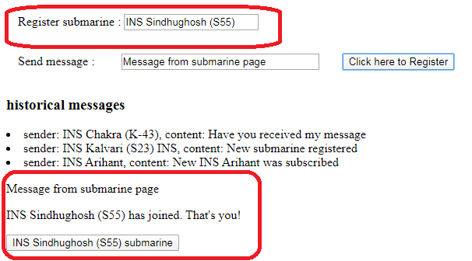

Now, we go back to the control page and refresh and see the newly joined submarine .

**Control room page.**

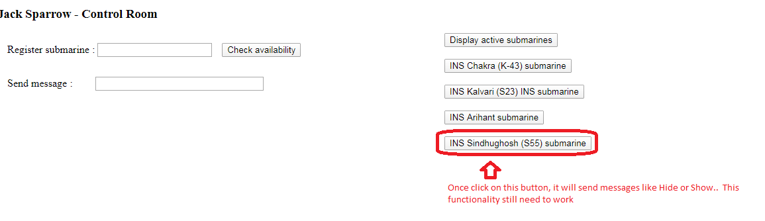

I am getting forbidden access from pubnub when I call few APIs like., unsubscribe, it seems my account was not completely authorized to do that.